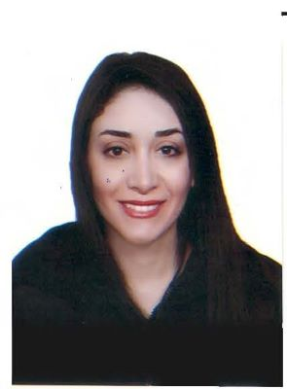**Mona Alakkam**

**Date of Birth:** 17 June 1987

**Nationality:** Syrian

**Civil Status:** Single

**Contact Information:**

* Tel: 00963 999 784 104
* Email: [kenmo198747@gmail.com](mailto:kenmo198747@gmail.com)

**Summary:**

A highly motivated and dedicated individual with over four years of experience in coordinating and managing law offices. Proficient in both Arabic and English, with a strong background in translation and advanced language skills. Experienced in preparing commercial letters, reports, and organizing office and staff requirements. Possesses strong leadership, presentation, and problem-solving skills, and is able to work effectively under pressure.

**Education:**

* Bachelor of Arts in English Language, Damascus University, Faculty of Arts and Humanities - Translation department.
* Bachelor of Engineering, Damascus University, Engineering Technical Institute.

**Work Experience:**

Administrative Manager at Law Office, Damascus (July 2020 - present).

* Prepare commercial letters related to office lawsuits (Arbitration, Civil, and Customs).
* Arrange conferences.
* Prepare reports for clients and inform them of the latest developments in their lawsuits.
* Check and classify documents according to each lawsuit separately.
* Organize and distribute work to employees as directed by the manager.

Executive Secretary at Law Office, Damascus (May 2018 - July 2020).

* Archive and index files and papers for each lawsuit.
* Organize and coordinate office and staff requirements.
* Organize the dates of visits and contacts of the manager.
* Manage and arrange meetings held by the manager.

**Skills:**

* Native Arabic speaker, good in spoken and written English.
* Advanced Translation Certificate, HITI.
* ICDL certificate.
* Microsoft Office (very good).
* Certificate of AutoCAD, TISHREEN University.
* Certificate of GIS, TISHREEN University.

**Personal Skills:**

* Leadership.
* Presentation skills (Good).
* Ability to work under pressure.

**References:**

Available upon request.